## Introduction

Five Traits

on-demand and self-service resource (no human interaction needed)

board network access (from anywhere)

resource pooling (provider shares resources with customers)

elastic/flexible resources

measured service (only pay for what customers need)

Why compelling

first wave = colocation saves physical space

second wave = virtualized data centers (virtual devices)user-controller and user-configured environment

save time of creating and maintaining the infrastructure

serverless ⇒ focus on code rather than infrastructure management

third wave = container-based

Second Wave ⇒

laaS = infrastructure as a service (like data centers)

raw compute + storage + network capabilities

pay for what they allocate

PaaS = platform as a service (resources based on application need)

pay for what they use

SaaS = software as a service (software in cloud rather than local machine)

ex. gmail

Ex. Google Cloud infrastructure uses multiple locations

app location ⇒ availability, durability, latency (package from source to destination)

zones (deployment of resources in a focused geographic area) <= regions <= multi-region

Region and Zone: Google Cloud geographic scopes are network latencies generally less than 1 millisecond

[Security](https://cloud.google.com/docs/security/infrastructure/design)

hardware infrastructure ⇐ secure boot stack + premises security

service deployment ⇐ encrypt of inter-service communication (RPC calls)

user identity layer ⇐ option to choose multiple factor

storage service layer ⇐ encrypt at rest

internet communication ⇐ Google Front End (GFE) + Dos Protection

operational layer ⇐ instruction detection + reduce insider risk + U2F (Universal Second Factor) use against phishing + SDE practices

### Tools

Kubernetes = service to mix and match microservices running across different clouds

Operation Suite = to monitor workloads across multiple cloud providers

Dataproc = big data system hadoop as a service

Quota to prevent over-consumption of resources by an error/attack

rate quota resets after a specific time

allocation quota governs number of resources

(configure billing account at product level to manage cost of a product)

### Cloud Hierarchy

policy is applied inherited recursively (downward)

Resource = lowest level

The right side is how the resources are organized. Those resources are used by Project

belongs to just one project

Project

can have different owners/users

Project ID (globally unique and immutable after creation)

Project name (mutable by user)

Project number (globally unique and immutable and created by google cloud)

Folder can contain projects and folders

Organization nodes

Ex. policy administrator + project creator

Tools

Identity and Access Management

role has permissions

user is assigned to role

Service account = giving permissions to a virtual machine rather than a person

needs to be managed

service account can be a resource

Cloud Identity to manage identities (create/remove)

4 ways to [interact](https://cloud.google.com/app) with Google Cloud

Cloud Console (web)

Cloud SDK and Cloud Shell

SDK (code runs periodically) gcloud, kubectl, gsutil, bq

Shell provides command-line access from web browser (no installation)

Cloud API

Cloud Mobile App

VPC = Virtual Private Cloud = a secure private cloud-computing model hosted in public cloud

connect to Google Cloud and internet

use firewall to restrict access to instances

create static routes to forward traffic to specific destinations

Compute Machine can choose machine

predefined machine

custom machine

Virtual Machine can be runned as a physical server

can be created with Google Cloud console, CLI or Compute Engine API

can build or run images of other operating systems and reconfigured VMs

* Preemptible/Spot VM with less features and limited to 24 h runtime but cheaper

AutoScaling

number of CPUs per VM ⇐ machine family + user quota

VPC

RP = router provisioning

Routing Table (build-in tool to forward traffic, no external IP needed, no RP)

Firewall (restrict access of in&out traffic, rules defined by network tags, no VP)

VPC peering (exchange traffic between VPCs). Shared VPC for IAM

Cloud Load Balancing

put it in front of all the traffics to balance load including multi-region failover

global HTTP for web app

SSL Proxy for secure socket

TCP Proxy for other TCP traffic like SSL

regional for…,

Regional internal for traffic inside your project

Cloud DNS (Domain Name Service)

programmable (can public and manage with Cloud Console)

use Cloud CDN to lower latency, with reduced load and to save money

Connect networks to Google VPC

IPSec VPN protocol (Cloud Router, Boarder Gateway Protocol)

Direct Peering (put router in same public datacenter as a PoP (point of presence)

Carrier Peering (through provider’s network)

Dedicated Interconnect (allows more than one direct private connections)

Partner Interconnect (useful if not reachable by a dedicated connection

## Google Kubernetes Engine (GKE)

### Difference services to manage workloads

| Name | Description: a managed environment … (for) |
| --- | --- |
| Compute Engine | for deploying VM  resides in a specific zone  persistent disks and optional local SSDs  global load balancing and autoscaling  per-second biling |
| Kubernetes Engine (GKE) | for deploying containerized application  built based on Compute Engine. Zone down ⇒ CE down ⇒ GKE down  naive choices: DB in Compute Engine like in a VM or put it in GKE  alternative: google managed cloud storage of DB  supports cluster scaling, persistent disks, auto node repair…  portability across multiple environment  ex. containerized/hybrid app, cloud-native distributed system |
| App Engine | for deploying application, code-first  streamlines application deployment  supports version control, integrated monitoring, logging…  ex. website, apps, gaming backends, RESTful APIs |
| Cloud Function | for deploying event-driven functions (code focused)  serverless + auto scaling + HTTP endpoint  ex. microserver architecture, mobile and IoT backends |

Lab

create a bucket with GCP console

Storage > Browser (create bucket with same name as the project)

Computer Engine > VM instance > Firewall (allow HTTP traffic)

Service Account >create with a name and download the key file

… with cloud shell

Activate cloud shell on the top right cornet

MY_BUCKET_NAME = “<>”

upload the credential key file

gsutil mb gs://$MY_BUCKET_NAME — to make a storage bucket

gcloud compute zone list | grep $MY_REGION —search zones in my_region

gcloud config set compute/zone $MY_ZONE —define preferred zone

gcloud compute instances create $MY_VNAME —create vm

gcloud compute instances list —list existing vms

upload a file to storage bucket

### Container

Why?

deployment includes hardware → kernel → dependencies → application code

VM allows multiple hardware on one physical PC

packaging on VM is wasteful

shared dependencies between applications cause problem ⇒ isolate kernel and dependencies (But redundant OS)

isolate image (application & dependencies)

Use of Linux technologies

processes in its own virtual memory address space (rapidly created and destroyed)

Linux namespace (!= Kubernetes namespace) used by containers to control what application can see process information…

cgroups used to control what application can use how much resources (CPU, memory…)

union file systems used to encapsulate application and their dependencies

Layers

dockerfile contains instructions (each creates a layer)

FROM … Base Image Layer (R/O) pulled from a public repository

copy command layer contains files copied from your built tools current directory

run command layer to build the application

the top layer states what command to run in the container

→ on top of the docker, we have R/O container layer → container

An application running in a container can only modify the topmost layer.

The topmost layer's contents are ephemeral. When the container is deleted the contents will be lost.

Other real-world practice:

build the image in one container and second container only gets what needed to run the application

containers allow shared images among containers

each container has its own data space

### Kubernetes

Features

open source ⇒ portability

automation (deploying, scaling, monitoring) ⇒ auto scaling

container management (user preferences and configuration) ⇒ resource limit

declarative configuration (state desired state to get it) ⇒ extensibility

imperative configuration (for quick temporary fix or declarative config)

additional features: supports both stateful (user and session data to be stored persistently) and stateless applications

GKE

as a managed service of Kubernetes

feature

fully managed + container-optimized OS + auto upgrade version + auto repair unhealthy nodes + cluster scaling + IAM + monitoring + seamless integration + integrated networking + cloud console

Computing Options

Code Run: stateless containers + auto scale up/down

### Kubernetes Architecture

kubernetes object = object spec (desired state) + object status (current state)

Pod = smallest deployable kubernetes object

contains 1…* containers

components

control plane coordinates entire cluster

kube-APIserver accepts commands, views change of cluster state, authenticates incoming request

kubectl to connect to kube-APIserver

any change to cluster state will be handled by kube-APIserver

etcd = clusters database to store state of cluster, dynamic information, confif…

kube-APIserver interacts with etcd (no direct user access)

kube-scheduler to schedule pod onto nodes

only select suitable nodes based on requirement (hardware, nodes, …)

NOT launching pods

kube-controller-manager

cluster state via kube-APIserver

manage workloads

kube-cloud-manager manages interact with underlying cloud providers

ex. Google Compute Engine

nodes run pods created by GKE as Compute Engine VM

kubelet = kubernetes agent on each node

kube-APIserver connects to kubelet of a node when we want to run pods on it

kubelet stars the pod and monitors lifecycle and reports to kubeAPIserver

kube-proxy

maintain network connectivity among pods in a cluster

(node pools in GKE to manage different kinds of nodes)

* regional cluster increase the availability of a cluster by replicating the control plane and nodes across multiple zones
* zonal and regional cluster cannot be converted

### Kubernetes Object Management

object defined in YAML/JSON file (multiple object definition in same file)

Format

apiVersion: kubernetes-api-version

kind: pod

metadata: —helps identifying the object

name:

labels: — organize groups or subgroups

uid generated by kubernetes

spec:

containers:

name:

image

* (kind, metadata.name) is unique
* kutectl get pods --selector=app=nginx

save file to version control repository

Deployment object to ensure that a defined set of Pods is running at any given time.

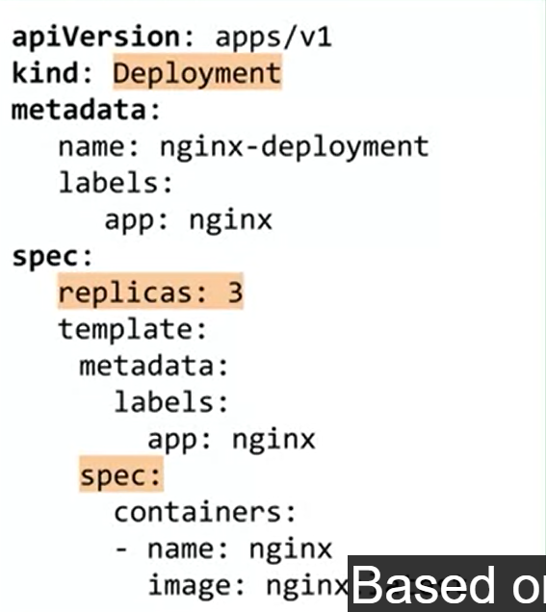

Namespaces

pod name needs to be unique in the same namespace

to implement resource quotas across your cluster.

to use object names that would otherwise be duplicates of one another.

3 default namespaces:

default

kube-system (created by kube)

kutectl command by default exclude items in kube-system

kube-public (to all users)

flexible way to apply namespace: kubectl -n demo apply -f mypod.yaml

Three primary types of services that provide load-balanced access and choose how pods are exposed

ClusterIP (default):

on an IP address that is only accessible from within this cluster.

NodePort:

on the IP address of each node in the cluster, at a specific port number.

LoadBalancer:

externally, using a load balancing service provided by a cloud provider

ex. loadbalancer in GKE allows access to regional network load balancing

Kubernetes controller objects

| ReplicaSet | identical pods run at the same time |
| --- | --- |
| Deployments | manage ReplicaSets & Pods to achieve declarative  no persistent identities for created pods  ex. to create a rolling upgrade of a Deployment  creates a 2nd ReplicaSet  increases the number of Pods in 2nd  decreases the number of Pods in the original ReplicaSet. |
| Replication Controllers | = ReplicaSets + Deployment (not recommended)  gives "front end" to ReplicaSets |
| StatefulSet | to deploy applications that maintain local state  = Deployment where Pods use the same container spec  unique persistent identities of created pods  stable network identity  persistent disk storage |
| DaemonSet | runs specific Pod on all/some subset of nodes |
| Job | creates 1…* pods to run a task  CronJob runs Pods on a time-based schedule |

Migrate for Anthos to change to Cloud

moves VMs to containers (automatic)

migctl migration generate-artifacts my-migration

### Kubernetes Workloads

kubectl

used by admin to communicate with kubeAPIserver and control clusters

cannot create or update cluster

config file ($HOME/.kube/config) contains target cluster name, credential for cluster

kubectl config view to see current config

connect to GKE cluster

gcloud container cluster get-credential [cluster_name] --zone [zone_name]

kubectl [command] [type] [name] [flags]

[command] = what you want to do (ex. get, describe, logs, exec…)

[type] = type of object (ex. pods, deployment, nodes…)

[name] = object name (kubectl get pods kubectl get pod my-test-app)

[fags] = special requests? (ex. kubectl get pod my-test-app -o=yaml)

--kubeconfig or --context

Deployments

declare states of pods

roll out updates + roll back pods + autoscale

great for stateless app

3 lifecycle states

progressing = task performed

complete = all updated to new version

failed = not completed

3 ways to create deployment

kubectl apply -f [deployment_file] by manifest file (create/update)

kubectl run [deployment_name] --image [image]:... by command line

GKE workloads menu

kubectl describe deployment [name] for more information

scaling

kubectl scale deployment [name] --replicas=#

cloud console to change replicas #

kubectl autoscale … (also in cloud console)

horizontal pod scaling ⇒ increase usage of resources

vertical pod scaling ⇒ recommendation for resource usage over time

update deployment (ramped strategy create new and delete old one-by-one)

kubectl apply -f [deployment_file] by manifest file

kubectl set image deployment [name] [image]

kubectl edit deployment/[name] to edit with vim editor

GKE console to update

blue/green deployment strategy

blue is the previous version, green is the new version during deployment

we update manifest file to direct traffic from blue to green when ready

Canary deployment strategy

gradually shift from blue to green

A/B testing to measure the effectiveness of functionality

shadow testing to run a new version hidden behind current version

test with user input but not affecting app behavior

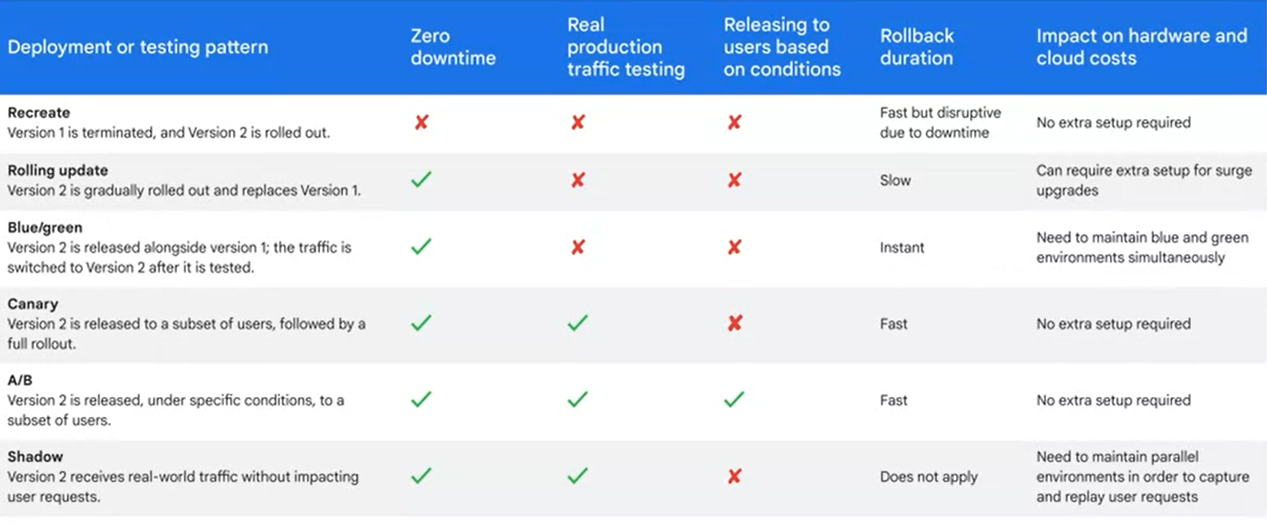

rolling back a deployment

kubectl rollback undo/history deployment name [--to-reversion=#]

pausing

kubectl rollout pause deployment [name] only affect following deployment

kubectl rollout resume deployment [name] resume affected deployment

kubectl rollout status deployment [name]

kubectl delete deployment [name]

Pod Networking

pod2pod communication within same node

ip address of pod must be routable

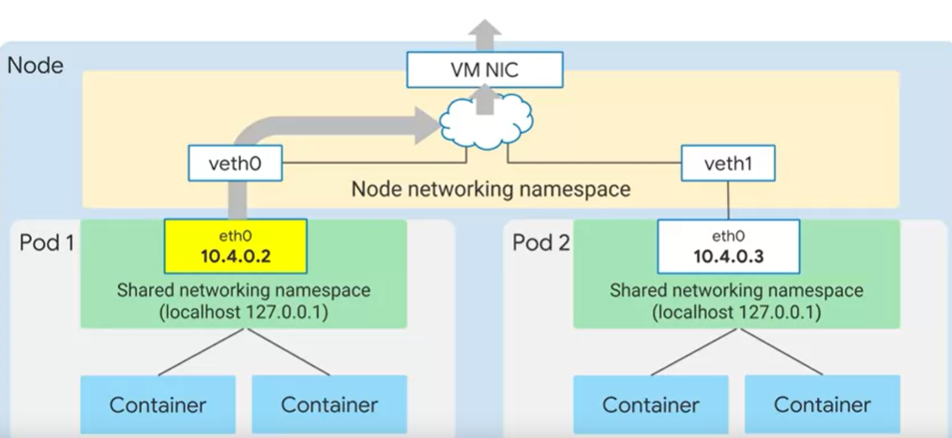

Volumes = storage

Volumes are ephemeral (same lifecycle as the pods)

PersistenVolumns (independent from pod lifecycle) in persistent Disk

uses PVC (persistent volume claim) to request persistent volume with requirements

ex. create a persistent volume manifest

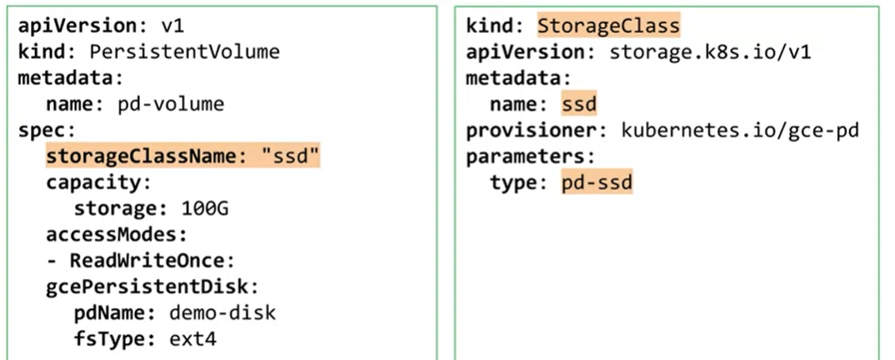

ex. adds persistent volume claim to pod

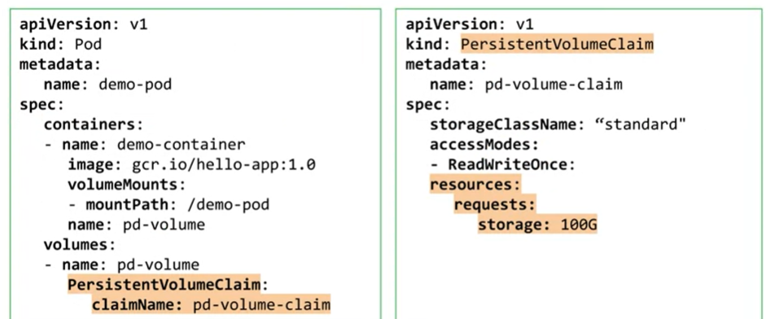

Types

emptyDIr = ephemeral (short-term lifecycle as the pods)

first default pod volume

configMap to inject app config data from Kubenetes into pods

Secret to store sensitive data

downwaardAPI to make downward API data available

## App Development Intro

Best Practice

code & environment

code repository (rollback)

(separate from code) dependency management tool

(separate from code) configuration setting

microservices (service boundary = business boundary)

keep UI responsive & minimize operations in user thread

design & development

loose coupling between publisher and subscriber

stateless components for scalability

cache content that is frequently accessed (both app and frontend data)

implement API gateways to make backend functionality available

\…

security & reliability

migration

repeatable deployment

Tools

gRPC (remote procedure call framework)

google cloud CLI (gcloud CLI = commandline) to manage cloud services

gcloud for common tasks, gsutil for storage (object, buckets), bq for bigquery…

Cloud Client Libraries (more user friendly than API calls)

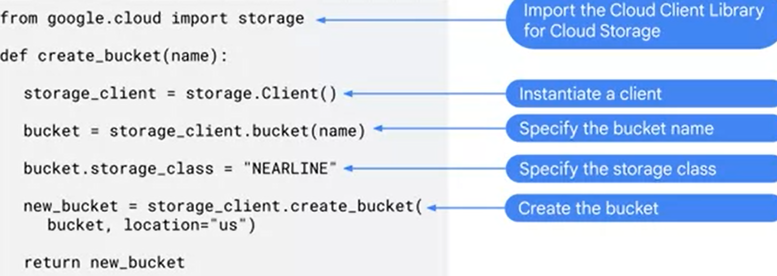

google cloud SDK

cloud shell (access to temporary VM)

cloud code to develop cloud application in IDE

kubernetes (GKE and YAML)

code run

gcloud beta emulators to install and manage emulators

\… (setup, qwiklabs)

Data Storage Options

| Cloud Storage | fully managed, highly reliable  cost-efficient  scalable object  object access via HTTP request  object name is the only key | good for videos, blobs, unstructured data, static web hosting |
| --- | --- | --- |
| Firestore | fully managed, serverless, NoSQL  scalable  native mobile/web client lib  real-time updates + offline features | good for mobile/app clients, document-oriented data, durable key data, hierarchical data… |
| Datastore | fully managed NoSQL  scalable  backward compatible to DataStore  (not relational database ⇒ not good for analytical data) | server app, semi-structured data, durable key data, hierarchical data…  (ex. user profiles) |
| Cloud Bigtable | high performance wide column NoSQL  sparsely populated table  scale  store TB/PB of data | operational/analytical app, MapReduce operations |
| CloudSQL | managed service (replication, failover, backup)  MySQL, PostgreSQL, SQL Server  relational  automatic failover ⇒ high reliability  proxy ⇒ secure access (without IP whitelist) | web framework  structured data  OLTP workloads |
| Cloud Spanner | relational  transactional consistency  global scale  high availability  (unlike CloudSQL, it requires every table to have a primary key) | high transactions |
| BigQuery | low-cost data warehouse  fully managed, scale, fast  serverless | OLAP (online analytical processing)  big data exploration and processing |

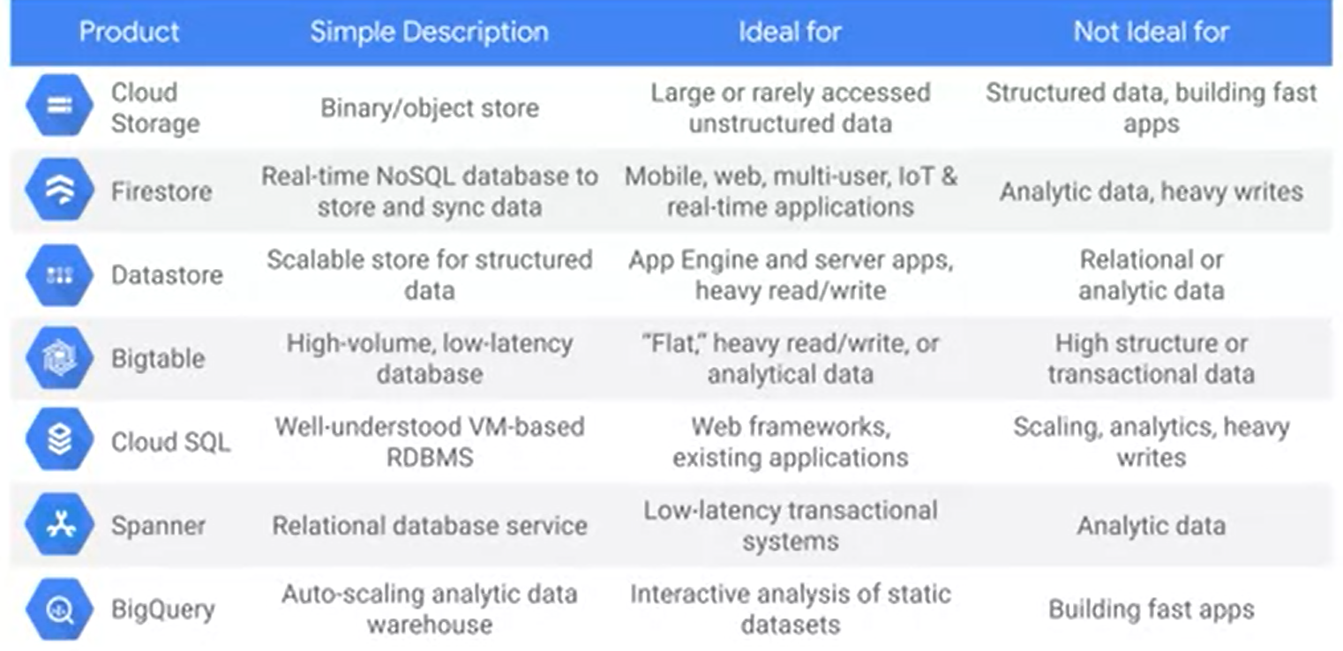]

storage option for mobile app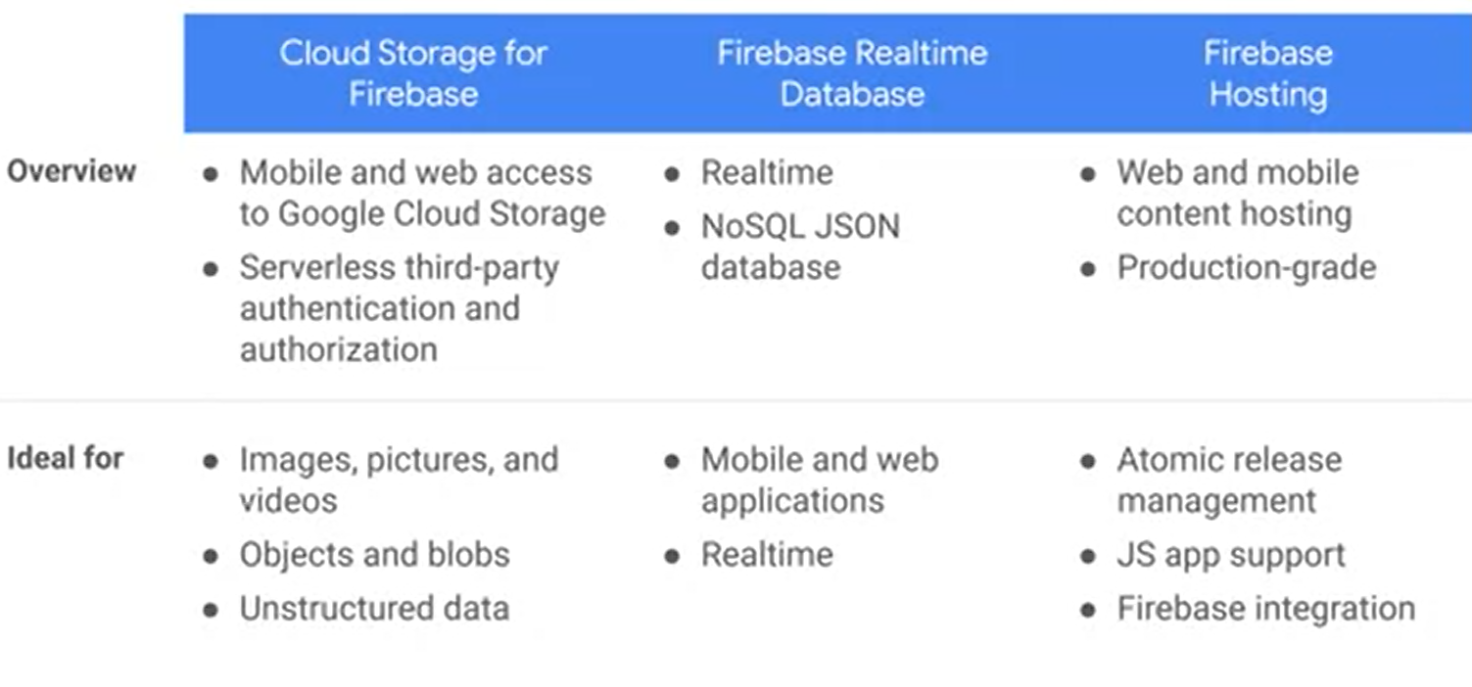

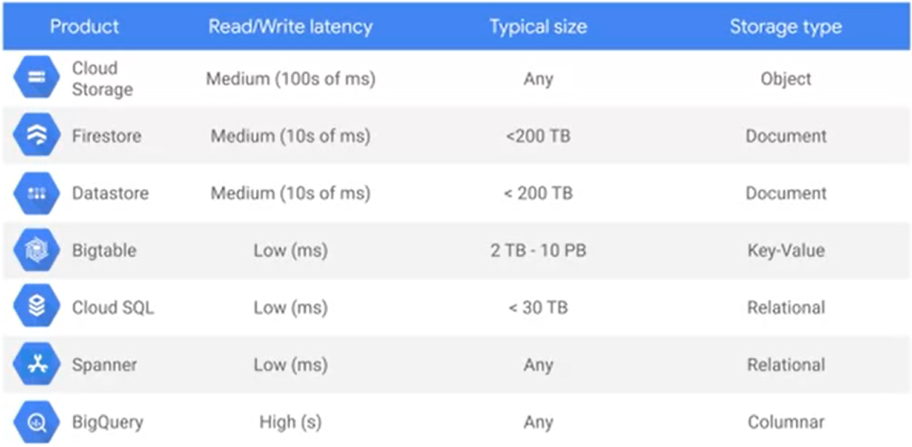

cache data to Memorystore

scalable web app, gaming, stream processing

fully managed service

fully protocol compatible with each engine

automates complex tasks

\…

Best practice for using DataStore

Datastore = Firestore in Datastore mode

Entity without ancestor = root

Ancestor path = path from root entity to leaf entity

two index = built-in + composite

composite index defined in index config file named index.yaml

gcloud datastore indexes create –create

gcloud datastore indexes cleanup –delete

(in datastore, kind of an object = table)

\…

Best practice for using cloud Storage

storage classes compare

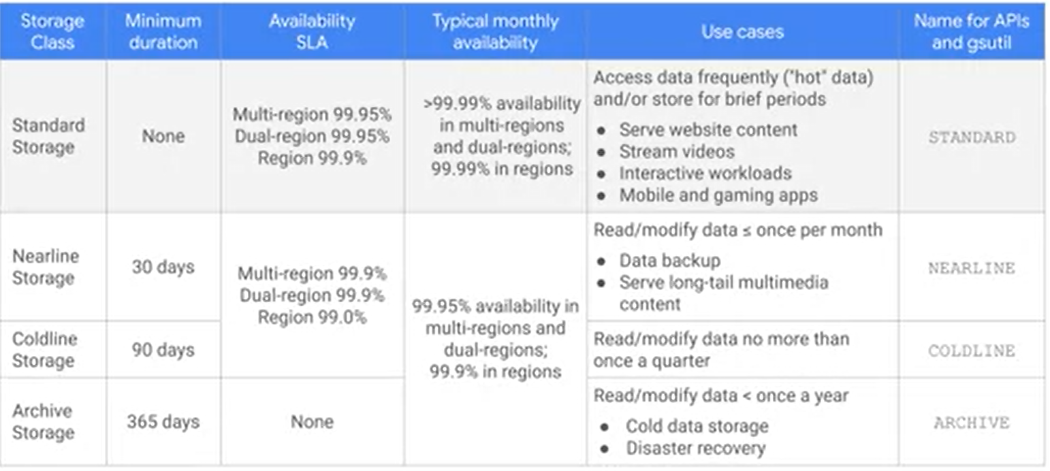

\…

## App Security and Integration

\…

[Pub/Sub](https://cloud.google.com/pubsub/docs/overview) to integrate

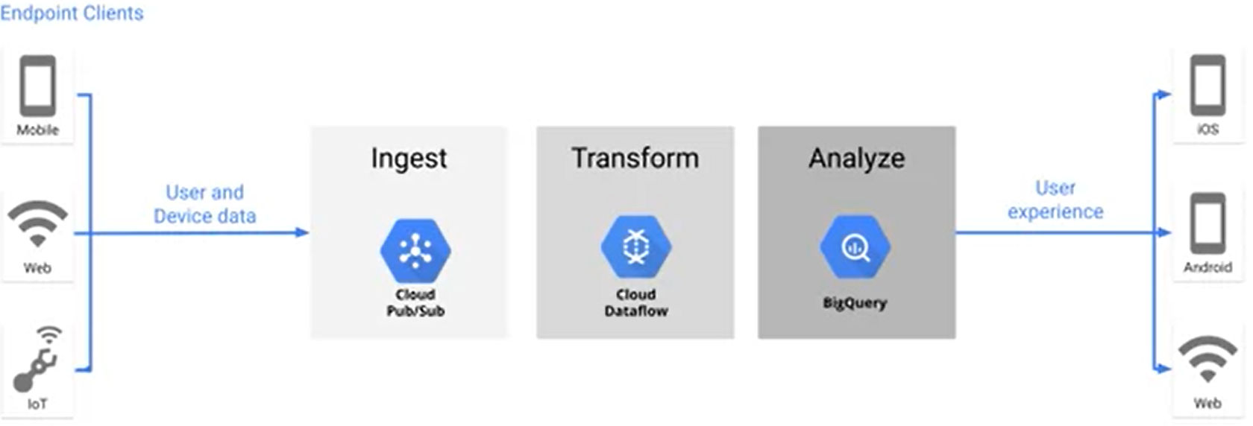

\…

Integrate AI

Models

pre-trained ML models

Vision API, Speech-to-text API, Text-to-Speech API, cloud Translation API, Cloud Natural Language API, Video Intelligence API

AutoML to bring your own data

ML Framework to build own model like Tensorflow, Vertex AI

Ex. Meeting Nanny to delete if the meeting room is empty by motion detection

Cloud Function

enables event-driven, serverless, highly scalable microservices

can be used by triggers or HTTP functions

\…

Manage APIs with Cloud Endpoints

Apigee API to manage APIs

Cloud Endpoint can be used for REST APIs and gRPC APIs

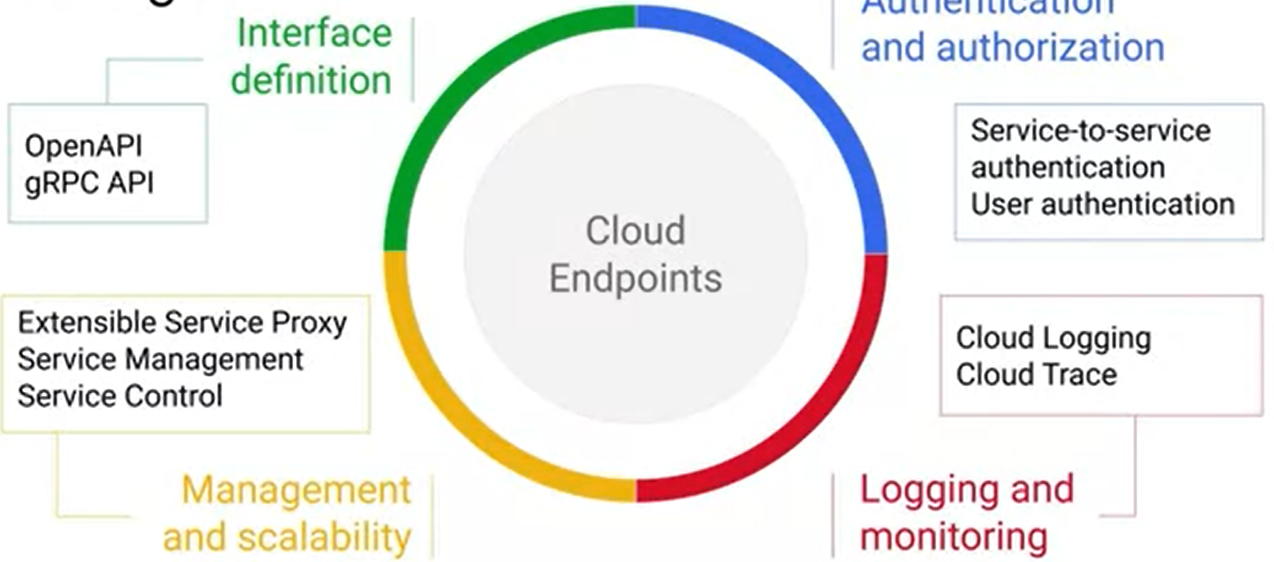

\…

## App Deploying, Debugging & Performance

### Deploying

Tools

Using container for consistency, loose coupling, workload migration, agility

Cloud Build to setup build pipeline and push created image with build information

Container Registry to create build pipelines with automatic trigger

Ex. each step is in a separate docker container

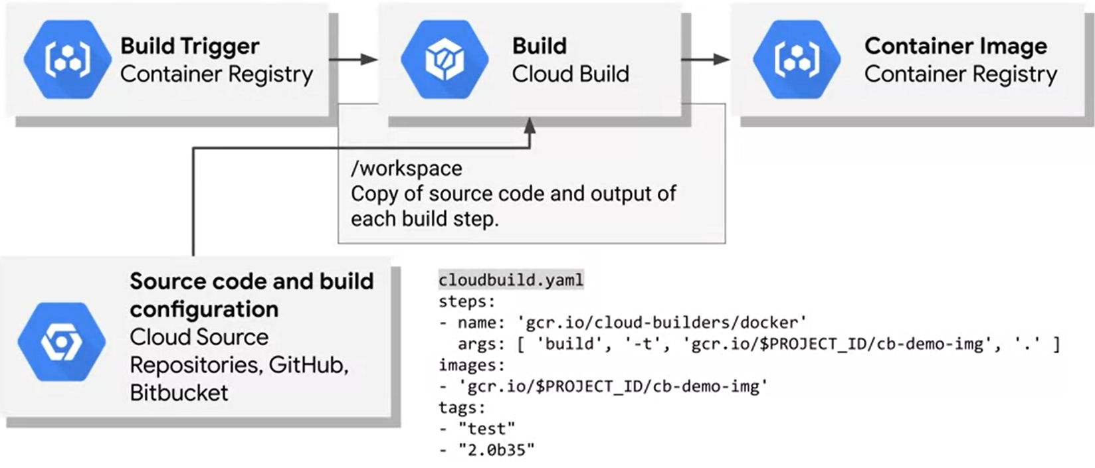

Terraform to provision Google Cloud resources

repeatable & parallel deployment, declarative language, template-driven

can be used on multiple public and private clouds

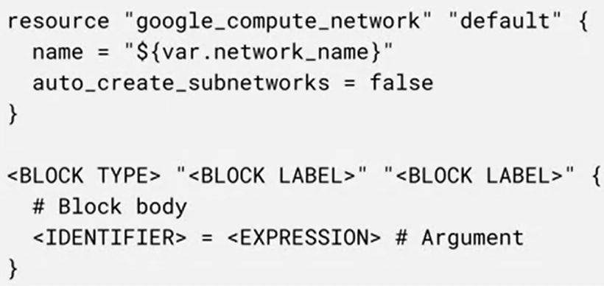

Cloud Foundation Toolkit to optimize Terraform deployment

to meet compliance and security requirements

\…lab

### Compute Options to Run Application

Compute Engine like VMs

GKE for cluster of VMs that run containers

Cloud Run(autoscale, no management) serverless, containers

scales HTTP application in containers

Cloud Functions (no management) serverless, functions

\…

### Monitoring

\…

## Application Development with Cloud Run

Basics

Cloud Run workflow

container-based: source code → build package and create image in container → deploy to Cloud Run

source-based: source code → deploy source code to Cloud Run

Cloud Run handles HTTPS serving

Use Cases

web app, public APIs

internal line-of-business app

microservices-based app

Cloud Run with Pub/Sub

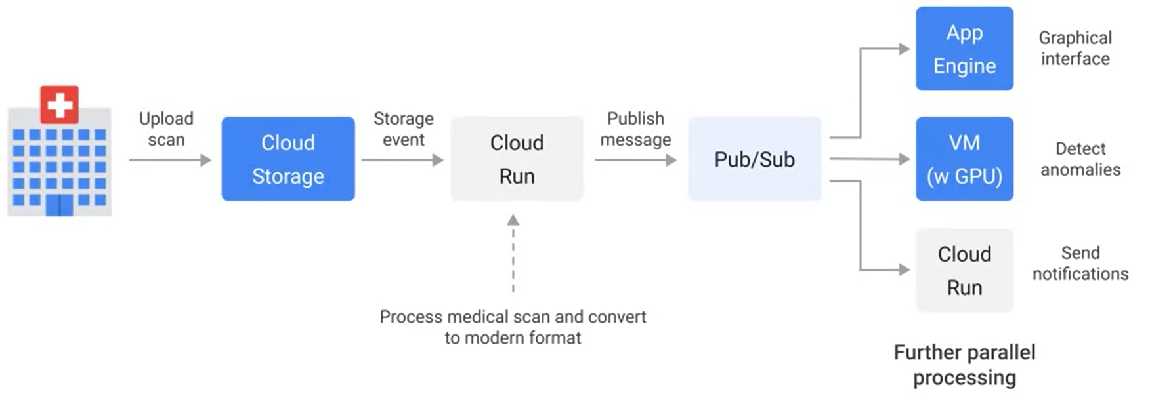

with Cloud Scheduler to handle job scheduling

* off-the-shelf app (remove container if not used) ⇒ CE or GKE
* long jobs that last for a long time and cannot be split into small jobs ⇒ CE or GKE
* massive stream and batch data processing ⇒ Dataflow
* train ML models ⇒ CE or GKE

Availability

automatic scaling to handle incoming requests

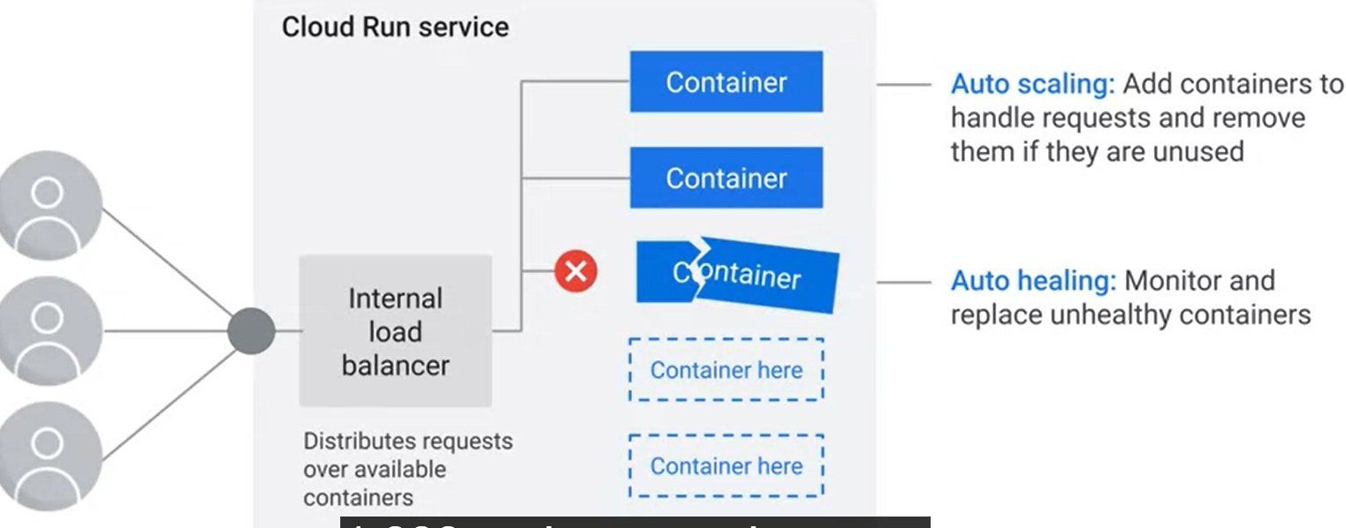

incremental app updates

immutable deployment

change → make a new revision (we can shift to new revision)

load balancing across zones in a region

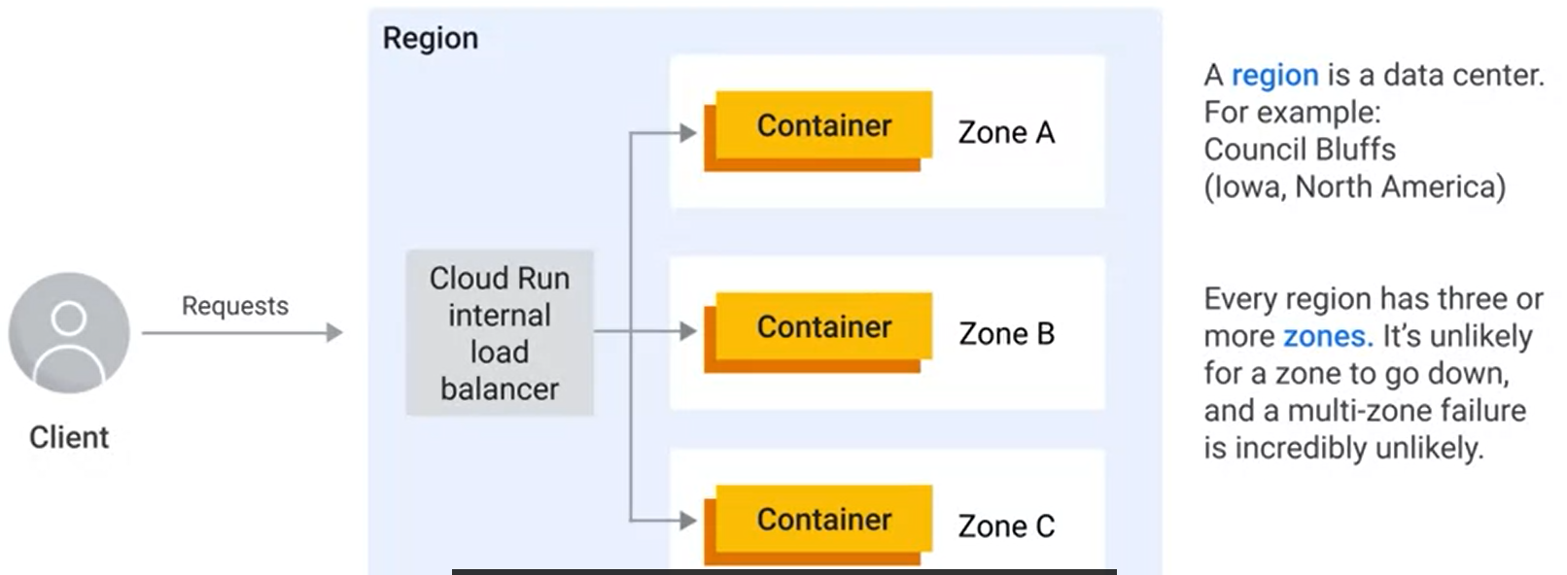

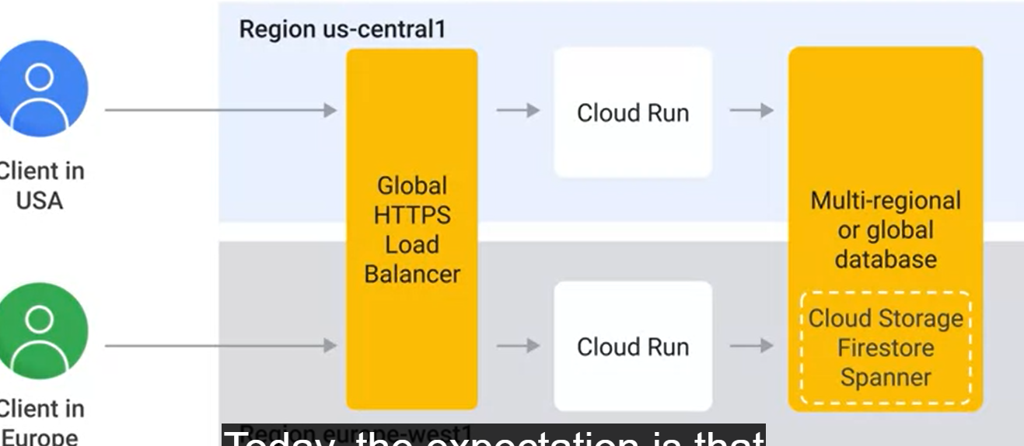

Serverless Concerns

autoscaling container ⇒ autoscaling cost

scaling mismatch with downstream system

vendor reliance

portability

Positioning on Google Cloud

Cloud Function/Run OR App Engine (runs on top of CE)

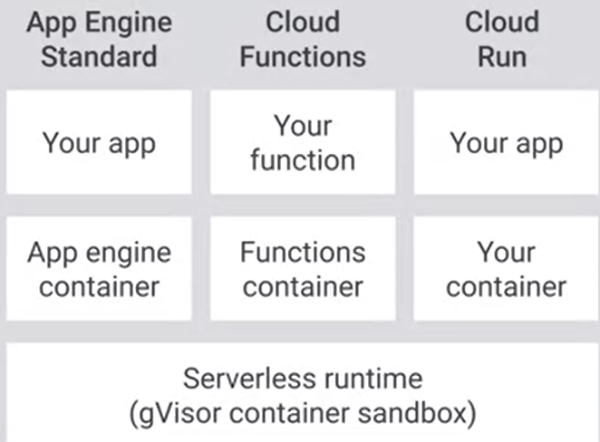

Running app on Cloud Run

Intro

image = archive with files

container = running container image

container image is self-contained

Cloud Run expect app to handle web requests (handles HTTPs for you)

Services

create a service to deploy a container image

service has a unique HTTPs endpoint

service keeps track of image config and changes made to it

Deploy

push image to **Artifact Registry** as an intermediate storage location

Artifact Registry = universal package manager = a docker repository for Cloud Run

gcloud run deploy --image=...

Cloud Run can only pull images from Artifact Registry and copy it to local

Manage Cloud Run via web, terminal, terraform…

on-demand service

only create container if more requests need to be handled

idle container will be shut down or stopped

any background threads need to be finished before returning request

to avoid, background tasks can be converted intro HTTP request

persistent data is stored in persistent downstream (not the container cache)

### Container Image

Intro

minimal container image only has one program file + command to run

system dependencies needs to be installed

runtime (may not required), Lib dependencies, source code, static assets, configuration needed to run application

ex. runtime = python, lib = pip, source code = python, assets = HTML, CSS, config = start “python server.py”

ex. Go doesn’t need runtime

config contains entry point + environment variables + user + working directory

Ex.

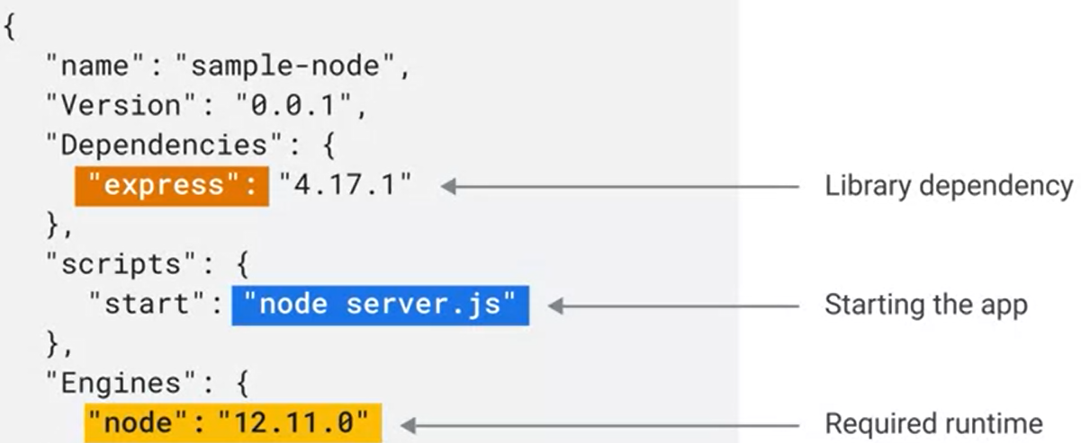

Docker

Steps

install system dependencies

install runtime

download lib dependencies

compile binaries

package files into container image

set container config

bulbs container image with dockerfile

ex.FROM = download base image to start

→ **COPY** files to the stage image

→ change config

→ RUN program to change files (run image on image)

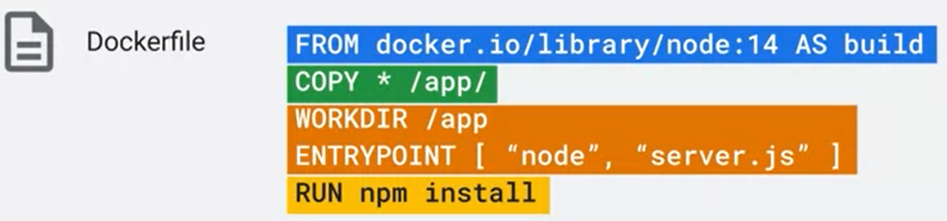

OTHER instructions can update the container image config

entry point to point the start of the program

ENV to set environment variable

Work DIR to set work directory

User to set user of the program

security and image size with Distroless

gets base image from prior steps

repeat FROM ⇒ multi-stage build

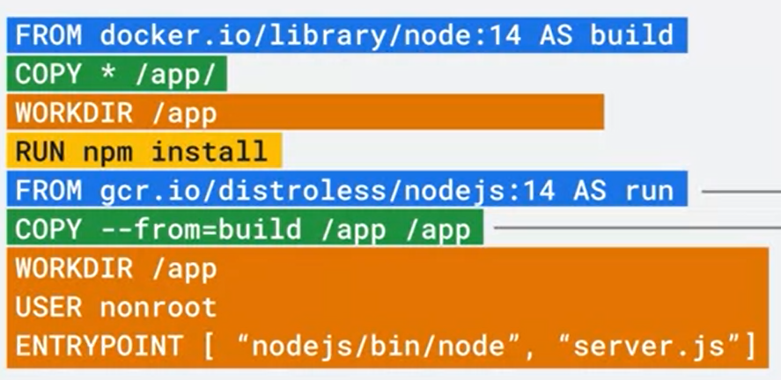

Buildpacks

hands-off approach to building a container image

turn source code to container image on autopilot

builder is used internally by App Engine and Cloud Functions

supports Go, Java, Node.js, Python, .NET Core

Cloud Run uses Google Cloud Buildpacks

### Container

Lifecycle

Starting state

download and materialize container image

run application

wait for application to accept TCP connection ⇒ ready

forward request

* pull container image from internal storage
  + artifact registry deploy image to Cloud Run for the fist time
  + Cloud Run stores image in internal storage (for later pull when starting container)

Serving request state to handle web request

usually never be stopped, BUT unexpected application exit or reaching mem limit ⇒ stop

no container ⇒ cold start

temporarily queue the request

queuing time of first time ⇐ start time of application

with minimum instance setting, no cold start (with cost)

busy containers ⇒ scale up

by default use max concurrency, but higher CPU usages lowers max concurrency

Idle state

CPU throttles the CPU to nearly zero for idle state

third party requests likely to fail

Shutting down state to stop gracefully

shutdown time is not deterministic

register a lifecycle hook to handle shutdown gracefully

Cloud Run send SIGTERM signal to application

10 s to handle the signal in application (save data, logging…)

without handling the signal → idle turns to stopped

Stopped state (final state)

normally not from serving state, BUT unexpected application exit or reaching mem limit ⇒ stop

Deployment of a new version

steps

change code → build and package a container image → push image to Artifact Registry → deploy to the service → wait for Cloud Run to deploy the changes

revision = copy of container image and service config

when new revision is ready, shift traffic to new revision → new and old autoscale

can set a split to 1…* revisions

by default, we use latest ready revision, but we can pin traffic to a specific revision

tagged revision has unique url (traffic splitting is not supported)

### Security

IAM Policy to check authorization

list of policy binding (binds a member/identity to a role)

3 types of policy binding

human identity (google account, group or domain)

machine identity (service account)

no login password like user account

other user/service account can act on behalf of a service account

service account are not members of Google Workspace domain

Cloud Run has client lib to authenticate API calls

all users (anonymous)

role = list of permissions and permission usually attached to API calls

⇒ IAM policy attached to a resource

Resource Hierarchy

every resource has IAM policy

some roles cannot be added to resource level (only project or root level)

higher level policy cannot be taken away by a lower level

Least Privileges

3 types of roles (DON’T grant basic roles in usual cases)

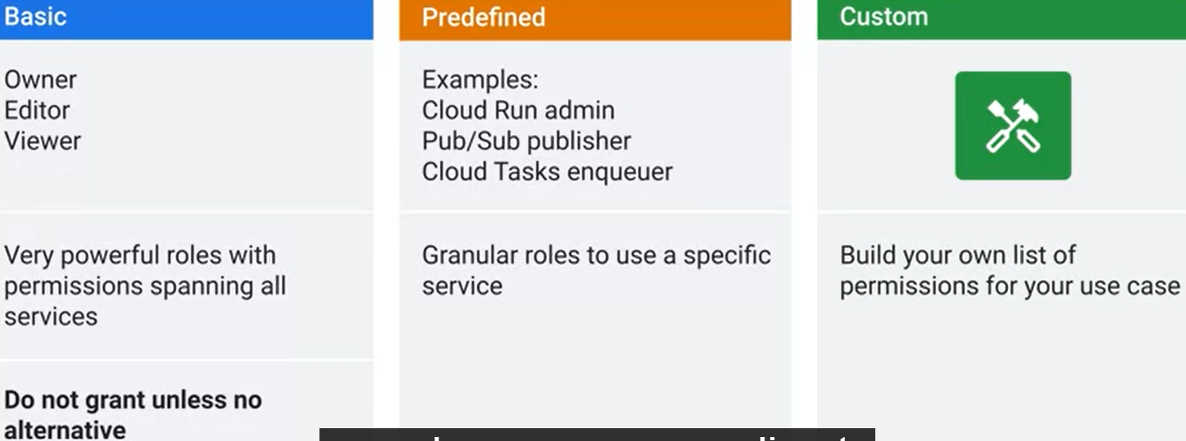

default service account (if not specified) has basic editor role on the project

### Serving Requests

3 ways to route requests in Cloud Run =

standard *.run.app domain + custom domain + HTTPs load balancer

global HTTPS load balancer ⇒ benefits and costs

Balancer as frontend

IP address (can be static)

SSL certificate as HTTPS Proxy

URL Map uses host and path-based routing to forward requests to backend services

combine multiple backend service on same domain with path-based routing

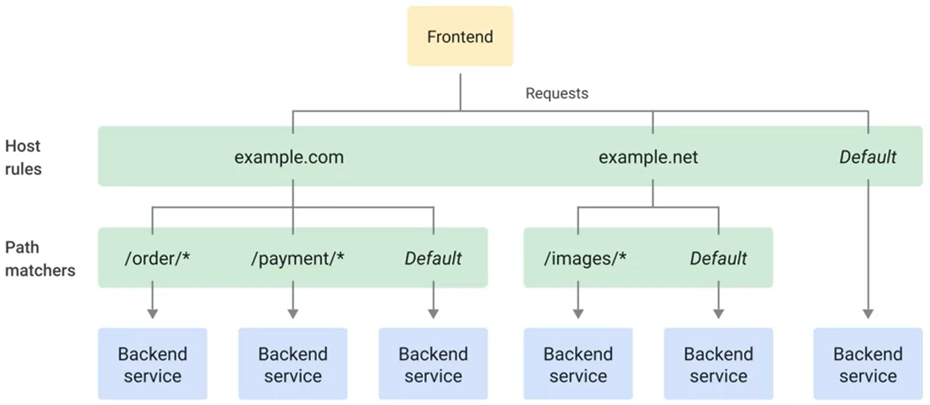

url masks in serverless NEG ⇒ route requests to diff Cloud Run without creating multiple backend services

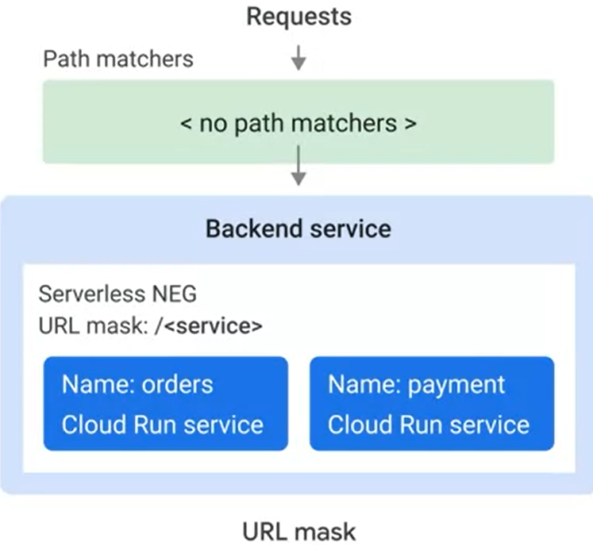

Cloud Run is regional and multi-regional load balancing routes request

Backend Service

Cloud Storage Buckets cannot be added

Cloud CDN = level of backend service

CDN = content delivery network (servers cashable content) has 3 modes

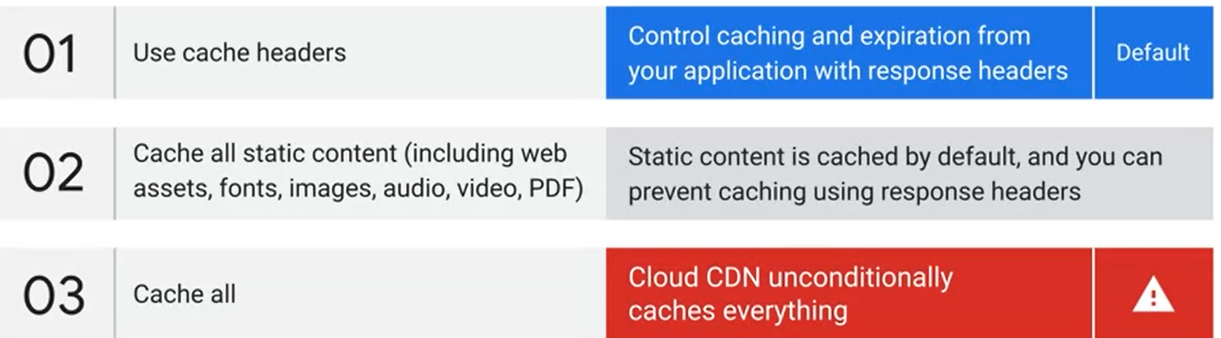

can increase content availability with Cloud CDN

serving content through it ⇒ improve website performance

serve more requests ⇒ less request for Cloud Run ⇒ cheaper

* multi-region uses the same IP address
  + 1…* serverless NEG in backend service (contains cloud run service)
  + cloud spanner to ensure the sql is consistent

### Protect In/Out-bound Traffic

3 ways to filter inbound traffic

Google Cloud Armor only filter Global HTTPs load balancer with content-based rule

can be added as a backend service (ex. filter with ip rule)

security policy rules attached to Armor backend service(s)

ingress proxy filter with source-based rule

VPC network souce

private ⇒ most strict setting

only allow service from VPC of the same project

prevent other cloud service from reaching your service

no pub/sub calls

HTTPs load balancer

allow VPC + HTTPs load balancer

other source

default setting that allows all three

IAM filter with identity-based rule

usually all users + service account

authenticated request has Google-signed OIDC token

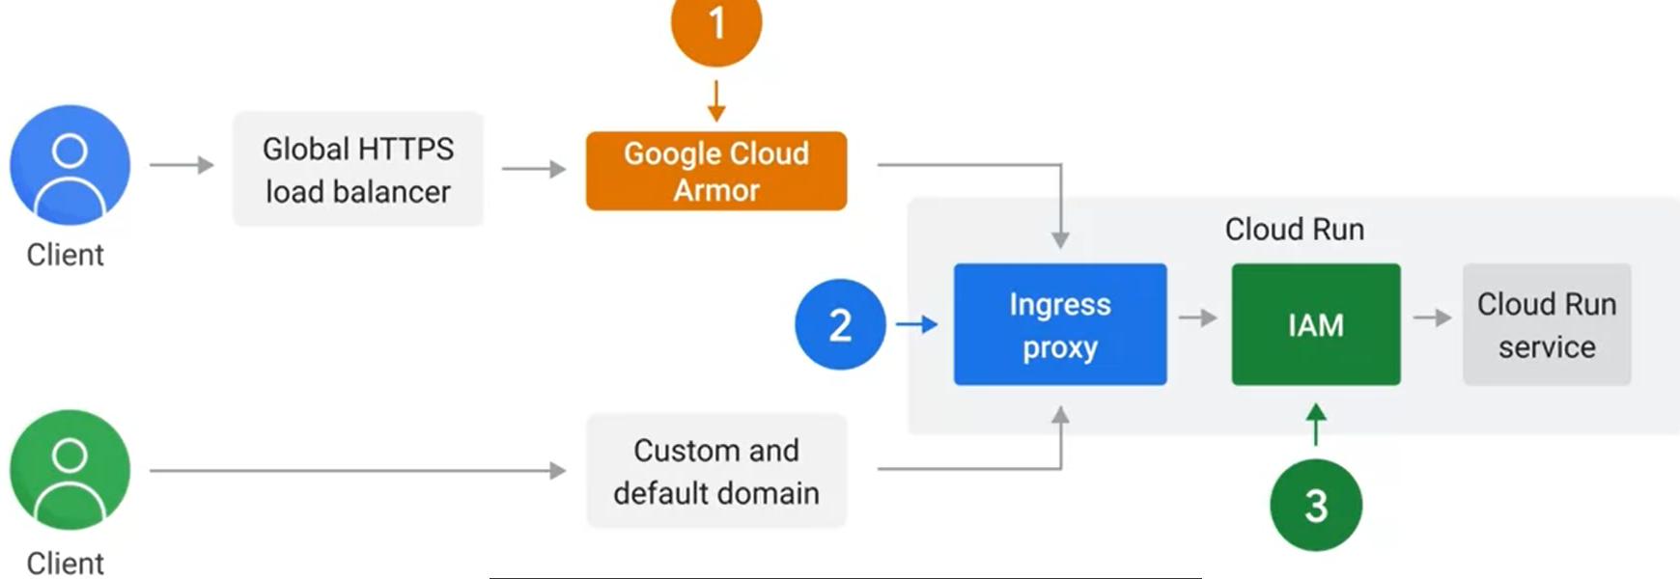

Serverless VPC access to protect outbound traffic:

cloud run uses a dynamic IP from public pool for outbound TCP/IP

Serverless VPC access connector to connect with internal IPs in VPC

route all traffic through serverless VPC Access connector if want to prevent traffic too dangerous

### Persisting Data

Connect Cloud SQL with

Cloud SQL Auth Proxy client (separate program to start on host)

app connects Auth Proxy with standard database protocol

clients needs Cloud SQL client role to connect

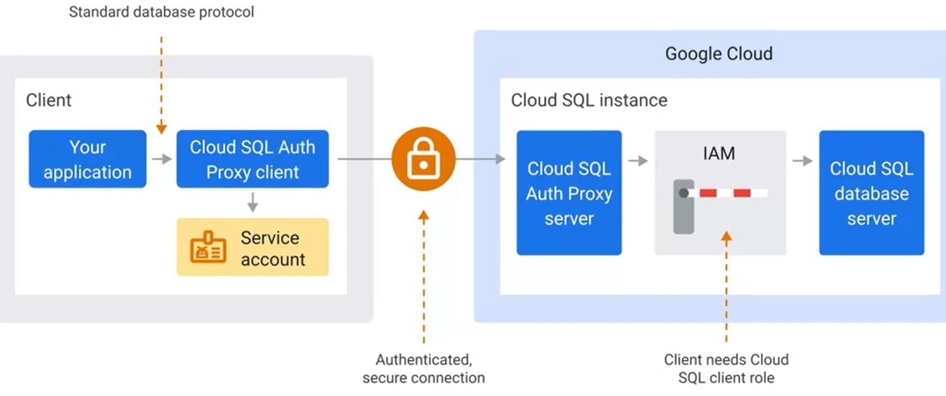

steps:

config to connect to Cloud SQL instance

app connects to Unix domain socket (between app and Auth Proxy)

service account to connect Cloud SQL is granted with right role

scaling 3 ways to control concurrency

limit max number of containers ⇒ may request queuing

connection pool to individual container

external connection pool

Direct SSL/TLS connection (needs to setup SSL and manage client certificate)

Memorystore = in-mem key-value databases

managed Redis or Memcached

needs a internal IP address in VPC to connect (same region as Memorystore)

VPC connector never loses connection instances ⇒ only scale up

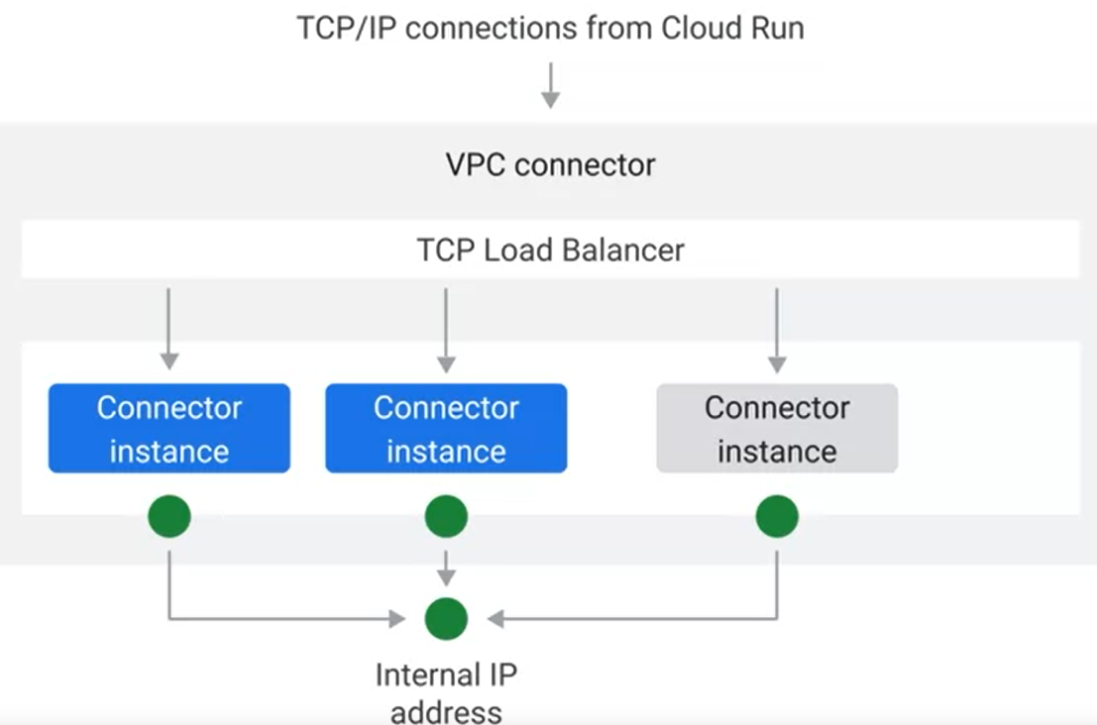

create Serverless VPC Access connector to connect from Cloud Run

ex. alternatives Cloud Storage/Spanner or Firestore

### Service-to-Service Communication

Request/Response

URL of services are globally unique, Cloud Run not have internal DNS

3 ways of URL discovery

pass URL with environment variables

call Could Run Admin API to retrieve URL of all services in same project

knowledge of service URL format

default URL of Cloud Run

http://[service_name]-[project_id_hash]-[region_code].a.run.app

Pub/Sub = asynchronous messaging service

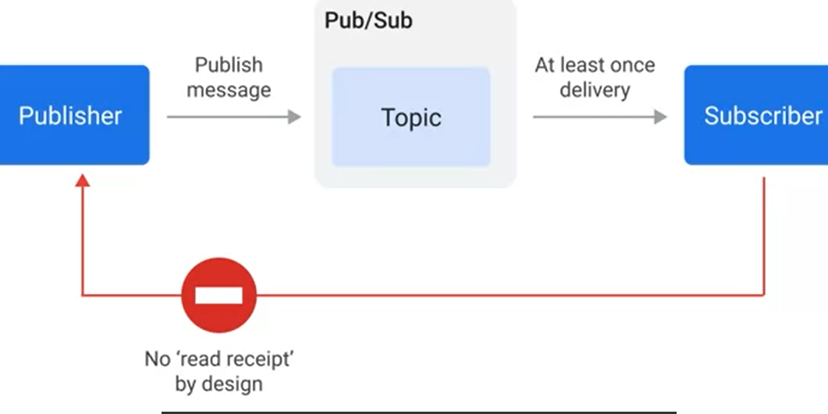

steps

create a topic where the publishing cloud run service can send message

create a push subscription (attached to the topic)

at least one delivery and retry failed message

⇒ no need for pub to wait for the response

undeliverable message can be saved

to avoid discarded messages, config dead-letter topic and monitor the message to that topic

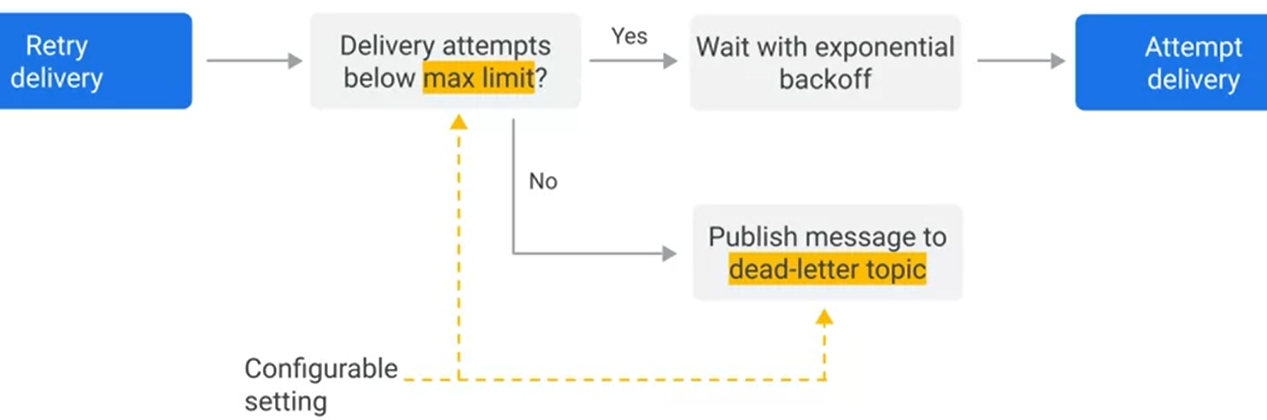

config push subscription to forward message to HTTPs URL of subscribing Cloud Run service

Many2Many relationship between pub and sub

invocation for one pub and one sub communicate

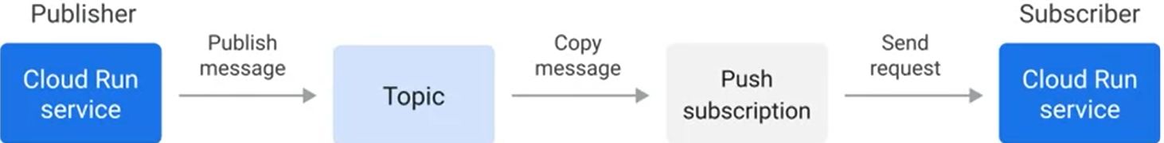

push subscription support IAM authentication (Google-signed …)

Handling Retires of Pub/Sub

when retry?

timeout trigger may retry when processing request

container exit while handling the request when out of mem

to avoid duplicate message being processed

same unique message ID when retry attempt

record message IDs in sub database

use lease to guard against parallel execution (store the lease in database and reject all messages with same ID with unexpired lease)

Receiving Events

what service sends what message to pub/sub topics (then received message by Cloud Run)?

cloud storage object change event

cloud build build status

artifact registry image notification

cloud scheduler notification on a schedule

BigQuery scheduled query status

[Eventarc](https://cloud.google.com/eventarc/docs/reference/supported-events) forwards Cloud Audit Log to Pub/sub

ex. cloud logging creates a Eventarc trigger and logs to it

Background tasks

Steps

publish a message to pub/sub for todo tasks

secondary service will perform the task

good for error handling

use Cloud Tasks over Pub/Sub if needs longer timeouts or request rate control

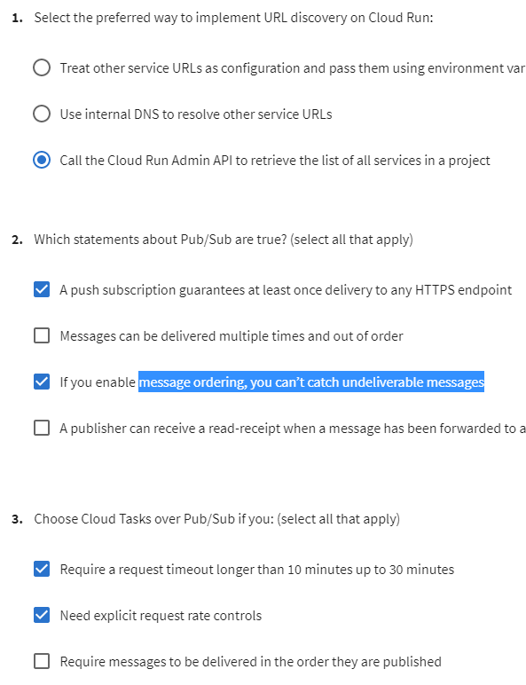

### Serverless Workflow

Cloud Workflow Benefits

execute a series of HTTP requests without error handling and retries

pass result from one as input to another request

use branching logic and conditional to create complex flows

connect to other cloud services like firestore

Example of pay for an order

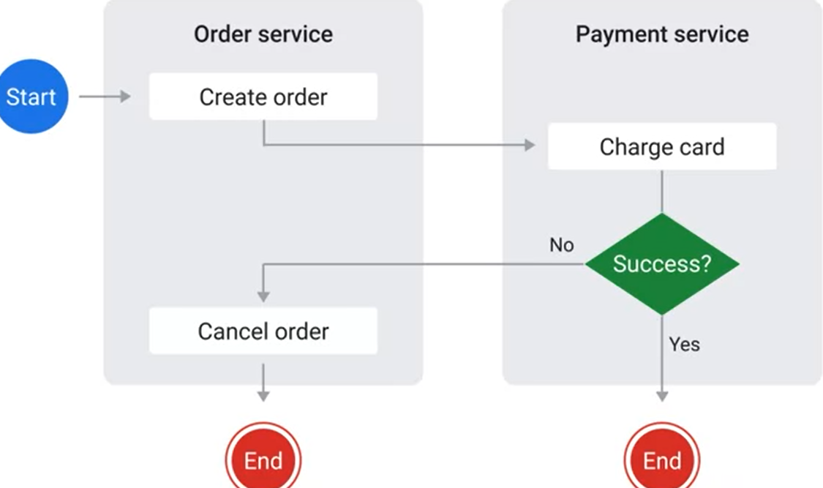

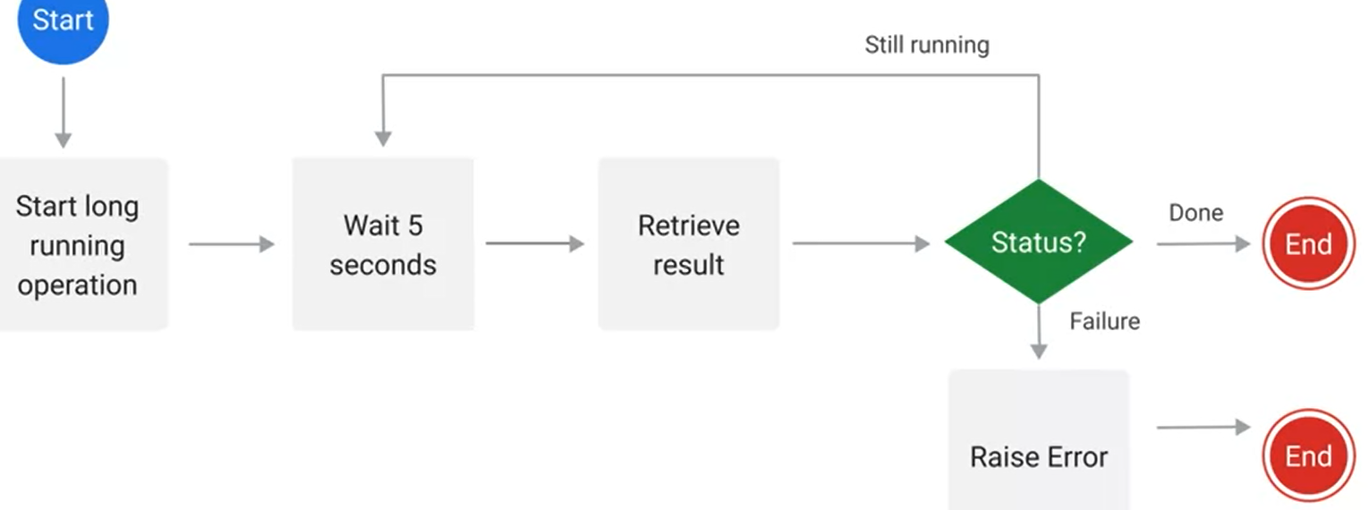

Workflow Implementation

define workflow in config file (YAML or Json)

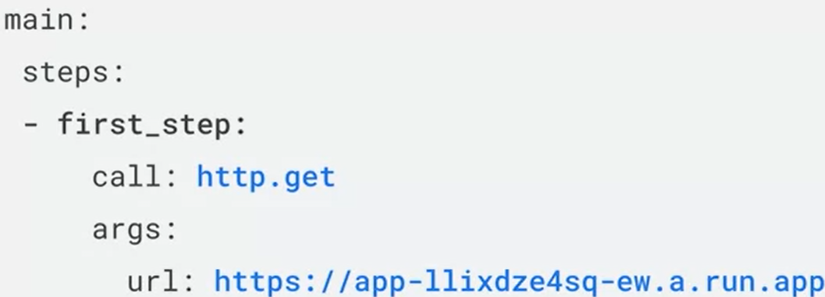

ASSIGN variables

CALL performs web request and stores response in mem

SWITCH makes decision based on mem stored value

RAISE error and stop

RETURN value in mem and stop

deploy to cloud workflow

execute workflow

* 4 ways to manage workflow: web, terminal, client lib, API (cloud scheduler)

CALL step

Intro

request to any HTTPS endpoint

authenticated by AIM

connector class to one of the supported Google Cloud services

authentication to Google APIs

long running operation without polling

build-in error handling with retries

convenient interface to pass parameters

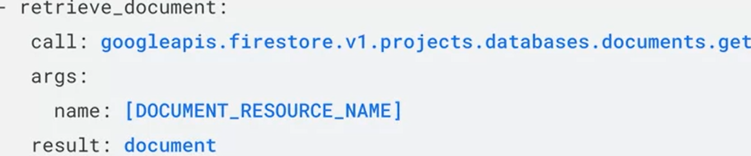

sleep call to suspend execution of a workflow temporarily

Ex use result of one as input of the other

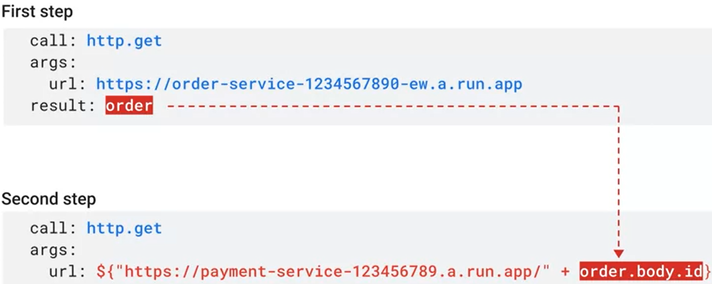

To call an authenticated Cloud Run service

grant Run Invoker role to workflow service identity

config workflow to pass an OIDC token

use OAuth2 tokens with APIs (not support connectors)

Expressions

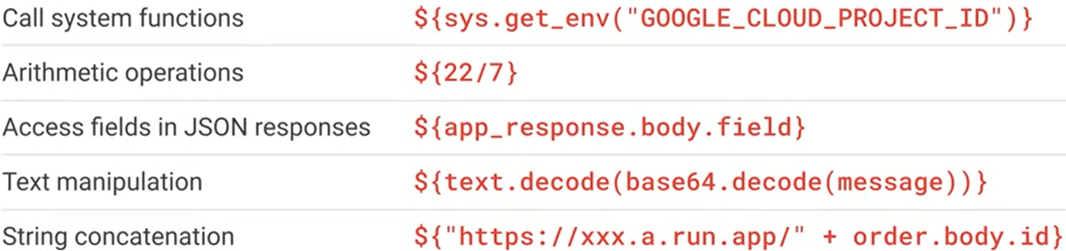

Retries

2 default retry predicates {http.default_retry} and {http.default_retry_non_idempotent}

both retries with 429 (too many requests) and 503 (service unavailable)

{http.default_retry} also retries when connection error, timeout, 502(bad gateway), 504 (gateway timeout)

Switch and case

Ex.

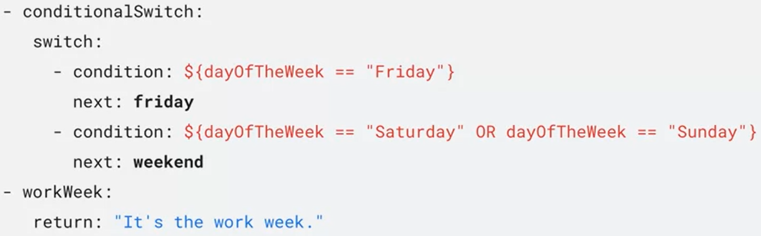

raise: “error message”